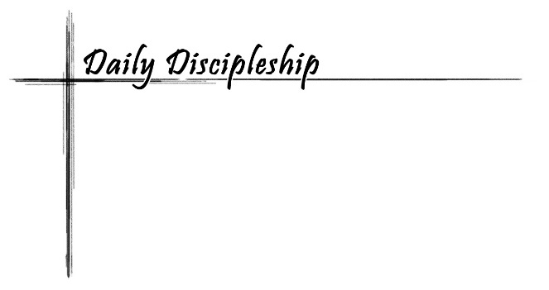**Study for Sunday, November 17 (B, L33) – Mark 13:1-8**

**Living in Christ:** *Live Expectantly /* **Focus Question:** *How do I live “expectantly”?*

**word** *of life*

**“This is but the beginning of the birth pangs.”** Mark 13:8 (NRSV)

Read Mark 13:1-8

*As he came out of the temple, one of his disciples said to him, "Look, Teacher, what large stones and what large buildings!" 2Then Jesus asked him, "Do you see these great buildings? Not one stone will be left here upon another; all will be thrown down."*

*3When he was sitting on the Mount of Olives opposite the temple, Peter, James, John, and Andrew asked him privately, 4Tell us, when will this be, and what will be the sign that all these things are about to be accomplished? 5Then Jesus began to say to them, "Beware that no one leads you astray. 6Many will come in my name and say, 'I am he!' and they will lead many astray. 7When you hear of wars and rumors of wars, do not be alarmed; this must take place, but the end is still to come. 8For nation will rise against nation, and kingdom against kingdom; there will be earthquakes in various places; there will be famines. This is but the beginning of the birth pangs.*

Chapter 13 of Mark is often called the “Little Apocalypse” because it describes the end of time. Some scholars compare this chapter with other apocalyptic writings such as the book of Daniel or Revelation. Yet, it does not have some of the characteristics of other apocalyptic literature, such as symbolic images and visions of the future. This chapter’s description leads the reader into the description of the death of Jesus.

The setting is the temple. The disciples remark about the architectural structure of the building. The large stones catch their eyes and interest. Like a good teacher, Jesus uses their question as a teachable moment, but he does not proceed with a class on geology, engineering, or architecture. To the surprise of the disciples, Jesus describes the destruction of the temple. (Mark 13:2)

1. *Describe the temple of Jerusalem. (Check to see if your Bible has an illustration of the temple. Sometimes these illustrations are found in the back of Bibles.)*
2. *What might have been other reactions to the destruction of the temple?*

After the conversation at the temple, Jesus moves to the Mount of Olives where the large temple could still be seen. His inner core of disciples, Peter, James, John and Andrew ask additional questions about the end of time. Their questions are basic—when and what signs? They desire to be ready for the end, but are unclear of the details. Jesus issues the disciples a sharp warning about those who want to lead them away from the teachings of Jesus. To add confusion, some of the false teachers will come in the name of Jesus.

1. *Describe someone who might want to lead the disciples astray.*
2. *How can the disciples be prepared for that type of person?*
3. *What does it mean to come in the name of Jesus?*

Jesus dispels any hope of peace as a sign of the end times. It is just the opposite. Things will get worse. There will be wars and rumors of wars as nations fight each other. There will be cosmic destruction as earthquakes and famines cause havoc in this world.

1. *How do you feel as you listen to this description?*
2. *Have you ever thought the end was near?*

Despite the dismal appearance, Jesus describes this as a beginning. The old must pass away. Just as women experience great pain in childbirth, so must the world go through birth pangs. God’s reign will triumph over the destruction.

1. *How might the world experience birth pangs?*
2. *What is the birth described by Jesus?*

**word** *among us*

Remember when the world prepared to turn over the calendar from 1999 to 2000? Some prepared for the end of the millennium by building underground living quarters. Others stored food, water, and supplies in their homes. Many purchased protection for their computers. A few spent their money on a huge party expecting no tomorrow. On New Year’s Eve night, the sky was full of fireworks.

1. *How did you bring in the year 2000?*
2. *What other ways did people deal with their fears that the world was coming to an end on January 1, 2000?*
3. *What other times have people wondered if the end of time was near?*
4. *How concerned are people today about the end of time?*

Each year during the church season of Advent, we prepare for Christmas, but we are also reminded of the second coming of Christ. We believe his second coming will usher in the end of time as we currently know it. We don’t know when or how Christ will come again. Since the details are vague, we are encouraged to be ready.

1. *What do you associate with Advent?*
2. *How do you feel when you hear someone discuss the end of time?*
3. *What will it be like when Christ comes again?*
4. *How often do you think about the second coming of Christ?*

Soon many will celebrate Thanksgiving. Traditionally, we gather around the table and give thanks for the ways God has blessed us during the previous year. Read through Mark 13:1-8 again. Despite the negative things to occur, listen for the ultimate victory of God.

1. *What if anything in this passage stirs an attitude of thanksgiving?*
2. *Do you ever wish you would know more about the end of time?*

Jesus describes the wars, earthquakes, and famines that occur before the birth pangs. Things are destroyed before God births something new. We are invited to live expectantly, trusting all is in God’s control, even when things look bleak.

1. *What does it mean for you to live expectantly?*
2. *What makes it so hard to live expectantly?*
3. *What new thing is God birthing in your life?*
4. *How might you get ready for the end of time?*

**Prayer of the Day**

Almighty God, your sovereign purpose brings salvation to birth. Give us faith to be steadfast amid the tumults of this world, trusting that your kingdom comes and your will is done through your Son, Jesus Christ, our Savior and Lord*.* Amen

**Dig Deeper**

Daniel 12:1-3

*last* **word**

Imagine this is your last day on earth

and ponder ways to spend it

as a disciple of Jesus.